
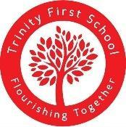
Primary R&Wv Curriculum Overview adapted for TFS

- The matters of central importance are included for reference.
- UC units are highlighted in grey.

Year Group | Autumn 1 | Autumn 2 | Spring 1 | Spring 2 | Summer 1 | Summer 2
Reception  EYFS | Unit 1  Why is the  word God so important to Christians?  (Creation) | Unit 2  Why do Christians perform Nativity plays at  Christmas? (Why is Christmas  special for  Christians?)  (Incarnation) | Unit 3  Being special: where do we belong?  (Thematic) | Unit 4  Why do Christians put a cross on their Easter garden?  (Why is Easter  special to  Christians?)  (Salvation) | Unit 5  Which places are  special and why?  (Thematic) | Unit 6  Which stories are special  and why?  (Thematic)
Year 1  KS1 | Unit 7  Who do  Christians say made the  world?  (Creation) | Unit 8  Why does  Christmas matter to Christians?  (Incarnation) | Unit 9  Who is Jewish and how do they live?  (God, Torah, the  People) | Unit 10  What do Christians believe God is like? (God) | Unit 11  What does it mean to belong to a faith  community?  (Thematic) | Unit 12  How should  we care for  the world and for others,  and why does it matter?  (Thematic)

Year 2  KS1 | Unit 13  What is the  good news  Christians  believe Jesus brings?  (Gospel) | Unit 14  What is the good news Christians believe Jesus  brings?  (Gospel) | TFS unit  Who is a Jew and how do they live? (Part 1) | Unit 16  Why does Easter matter to  Christians?  (Salvation) | TFS unit  Who is a Jew and how do they live? (Part 2) | Unit 18  What makes some places  special to  believers?  (Thematic)
Year 3  LKS2 | Unit 19  What is it like for someone to follow God? (People of  God) | Unit 20  What is the Trinity and why is it  important for  Christians?  (Incarnation/God) | TFS unit  How do festivals and worship show what matters to a Jew? | Unit 22  How do festivals  and family life show what matters to  Jewish people?  (God, The Torah, The People) | Unit 23  What do Christians learn from the creation story?  (Creation/Fall) | Unit 24  How and why do people try to make the  world a better place?  (Thematic)
Year 4  LKS2 | Unit 25  What kind of world did  Jesus want?  (Gospel) | Unit 26  For Christians,  when Jesus left; what was the  impact of  Pentecost?  (Kingdom of God) | Unit 27  What do Hindus  believe God is like? (Brahman, atman) | Unit 28  Why do Christians call the day that  Jesus died ‘Good Friday’?  (Salvation) | Unit 29  What does it mean to be a Hindu in Britain today?  (Dharma) | Unit 30  How and why do people  mark the  significant  events of life? (Thematic)

Year group Bible Stories

Bible Story | Autumn Term | Spring Term | Summer Term
Stick sheet in front cover or front page of RE Books. Children can add to it each time they hear the story.   | - Listen to the story | - Listen to the story  - Teacher asks questions about the story  (ideas in bible story folder)  KS2 children may have their own questions to ask! | - Listen to the story  - Teacher or children ask questions about the story  - Digging Deeper - Discuss what the meaning of the story might be or the message that we should take from the story.

EYFS Bible Story: Noah's Ark

Genesis 6:9 – 9:17
Noah built an ark to save his family and two of every animal from a great flood, showing God’s care and promise to protect life.

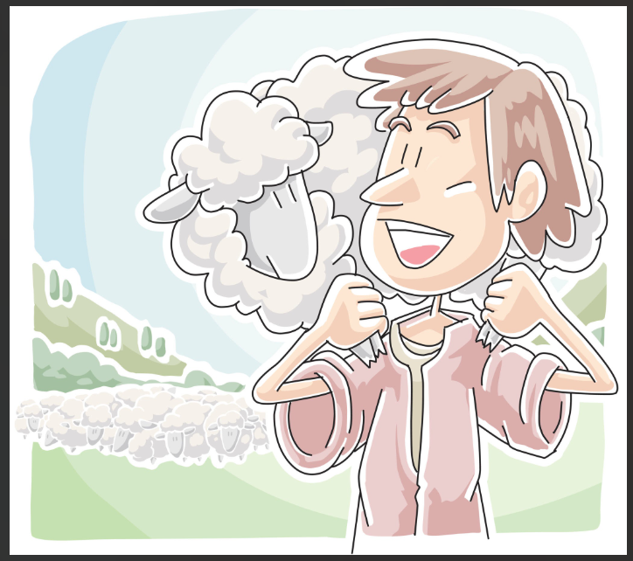
Yr1 Bible Story: The Lost Sheep

Matthew 18:12–14 & Luke 15:3–7
Jesus told a story about a kind shepherd who leaves 99 sheep to search everywhere until he finds the one missing sheep, showing how much God loves and cares for each one of us.

Yr2 Bible Story: The Prodigal Son

Luke 15:11–32
Jesus told the story of a son who left home and wasted all his money, but when he returned sorry and repentant, his loving father forgave him and welcomed him back with open arms.
Yr3 Bible Story: The Feeding of the 5000

Matthew 14:13–21 Mark 6:30–44 Luke 9:10–17 John 6:1–14
Jesus fed a crowd of 5,000 people with just five loaves of bread and two fish, showing God’s power to provide for everyone.

Yr4 Bible Story: The Good Samaritan

Luke 10:25–37
Jesus told the story of a Samaritan who helped a hurt stranger when others would not, teaching us to love and care for everyone, no matter who they are.

