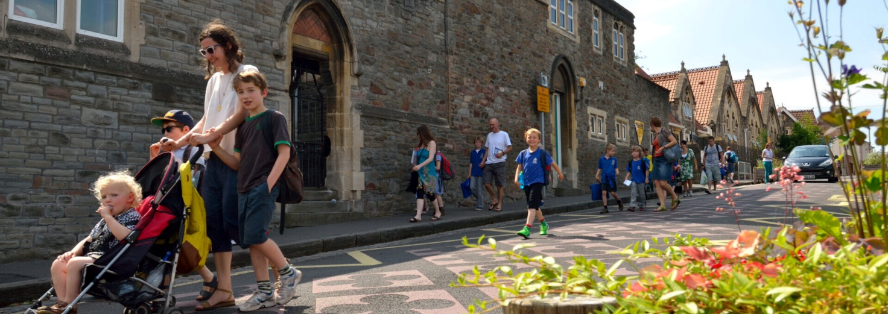
Sustrans DIY Streets intervention ‘street carpet’ and planters creating a safer place for pedestrians and cyclists. Ashton Gate Primary, Bristol. Credit: ‘J Bewley/Sustrans’ ©2013, Sustrans

Safer School Streets Update: Trinity First School
We are happy to announce, that after much planning, Frome’s Safer School Streets trial will start in Spring 2024. The purpose of the scheme is to improve the safety and wellbeing for everyone by prioritising and encouraging active modes of travel such as walking, cycling and scooting, while reducing traffic volume, traffic speed and improving air quality.
During the 18 month trial there will be short timed vehicle restrictions outside Trinity, Critchill, Oakfield and Avanti Park schools during term times as follows:
Location | Morning vehicle restriction times | Afternoon vehicle restriction times
Critch Hill (to Whitemill Lane)  Oakfield Road (outside Oakfield Academy)  Nunney Road (outside Trinity First School) | 8:10-9:00 | 2:45-3:30
Park Road (up to Avanti Park School) | 8:25-8:55 | 3:00-3:30
Residents, blue badge holders, buses and emergency services will be exempt from restrictions. Traffic between Nunney and Frome will be required to use the bypass at these times.
All parents and staff are encouraged to travel actively (walk, wheel, scoot or cycle) where possible, and families needing to drive are asked to park a short distance away from the school gate and walk the remaining journey. You can find out more about the scheme, see the designs and sign up to the School Streets newsletter on the School Streets website here.
Ahead of the start of the scheme we are asking parents and staff to complete a survey about their current travel behaviours and feelings about the area. Please follow this link to the survey.

Frome Town Council are looking forward to working with Trinity First School and engaging the children in some fun activities to highlight the benefits of active travel and how to keep safe on the way to school. More information will follow.

