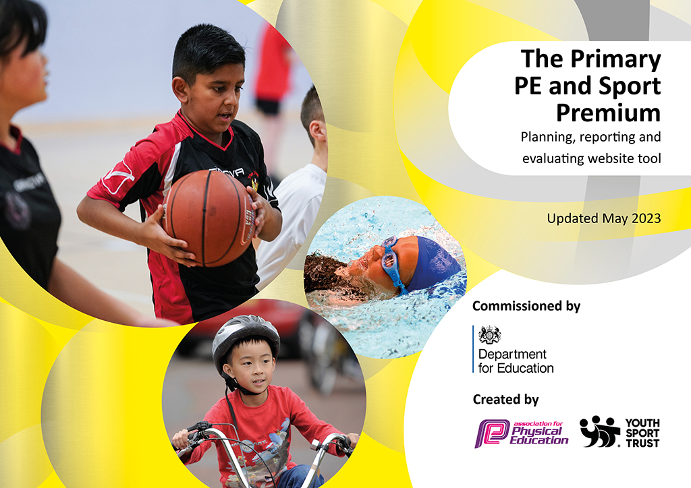
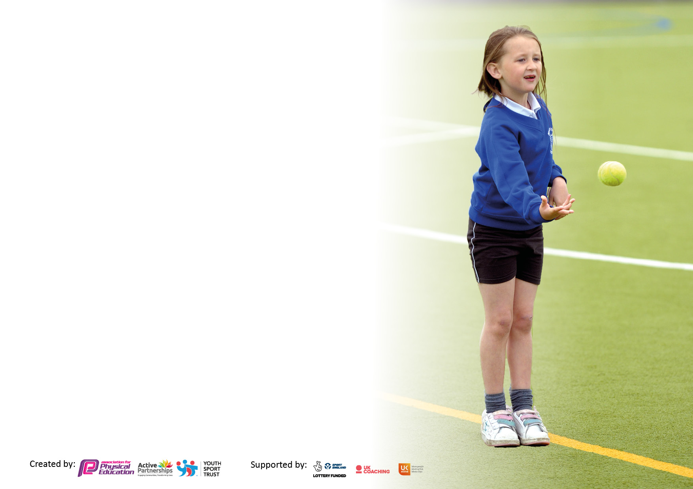

It is important that your grant is used effectively and based on school need. The Education Inspection Framework makes clear there will be a focus on ‘whether leaders and those responsible for governors all understand their respective roles and perform these in a way that enhances the effectiveness of the school’.

Under the Quality of Education Ofsted inspectors consider:
Intent - Curriculum design, coverage and appropriateness
Implementation - Curriculum delivery, Teaching (pedagogy) and Assessment
Impact - Attainment and progress

To assist schools with common transferable language this template has been developed to utilise the same three headings which should make your plans easily transferable between working documents.

Schools must use the funding to make additional and sustainable improvements to the quality of Physical Education, School Sport and Physical Activity (PESSPA) they offer. This means that you should use the Primary PE and sport premium to:

- Develop or add to the PESSPA activities that your school already offer
- Build capacity and capability within the school to ensure that improvements made now will benefit pupils joining the school in future years
- The Primary PE and sport premium should not be used to fund capital spend projects; the school’s budget should fund these.

Pleasevisitgov.ukfortherevisedDfEguidanceincludingthe5keyindicatorsacrosswhichschoolsshoulddemonstrate animprovement.Thisdocumentwillhelpyoutoreviewyourprovisionandtoreportyourspend.DfEencouragesschools to use this template as an effective way of meeting the reporting requirements of the Primary PE and Sport Premium.

We recommend you start by reflecting on the impact of current provision and reviewing the previous spend.

Schools are required to publish details of how they spend this funding, including any under-spend from 2021/2022, as well as on the impact it has on pupils’ PE and sport participation and attainment. All funding must be spent by 31st July 2023.

We recommend regularly updating the table and publishing it on your website throughout the year. This evidences your ongoing self-evaluation of how you are using the funding to secure maximum, sustainable impact. Final copy must be posted on your website by the end of the academic year and no later than the 31st July 2023. To see an example of how to complete the table please click HERE.

Details with regard to funding
Please complete the table below.

Total amount carried over from 2021/22 | £16,861
Total amount allocated for 2021/22 | £18,350
How much (if any) do you intend to carry over from this total fund into 2022/23? | £8,811
Total amount allocated for 2022/23 | £18,308
Total amount of funding for 2023/23. To be spent and reported on by 31st July 2023. | £32,478
Swimming Data
Please report on your Swimming Data below.

Meeting national curriculum requirements for swimming and water safety.

N.B. Complete this section to your best ability. For example you might have practised safe self-rescue techniques on dry land which you can then transfer to the pool when school swimming restarts.
Due to exceptional circumstances priority should be given to ensuring that pupils can perform safe self rescue even if they do not fully meet the first two requirements of the NC programme of study
What percentage of your current Year 6 cohort swim competently, confidently and proficiently over a distance of at least 25 metres?  N.B. Even though your pupils may swim in another year please report on their attainment on leaving primary school at the end of the summer term 2022.  Please see note above | % N/A
What percentage of your current Year 6 cohort use a range of strokes effectively [for example, front crawl, backstroke and breaststroke]?  Please see note above | % N/A
What percentage of your current Year 6 cohort perform safe self-rescue in different water-based situations? | % N/A
Schools can choose to use the Primary PE and sport premium to provide additional provision for swimming but this must be for activity over and above the national curriculum requirements. Have you used it in this way? | Yes/No

Action Plan and Budget Tracking
Capture your intended annual spend against the 5 key indicators. Clarify the success criteria and evidence of impact that you intend to measure to evaluate for pupils today and for the future.

Academic Year: 2022/23 | Total fund allocated: | Date Updated:
Key indicator 1: The engagement of all pupils in regular physical activity – Chief Medical Officers guidelines recommend that primary school pupils undertake at least 30 minutes of physical activity a day in school |  |  |  | Percentage of total allocation:
 |  |  |  | %
Intent | Implementation |  | Impact
Your school focus should be clear what you want the pupils to know and be able to do and about  what they need to learn and to  consolidate through practice: | Make sure your actions to achieve are linked to your intentions: | Funding allocated: | Evidence of impact: what do pupils now know and what can they now do? What has changed?: | Sustainability and suggested next steps:
To continue to increase the stamina for sustained exercise across the school for all pupils. | Ensure PE equipment is fully stocked and maintained to a good standard in order for staff to deliver high quality PE lessons. Audit resources and order any new resources needed throughout the year. | £33 | Appropriate equipment in school in order to teach high quality PE lessons. | Audit of PE equipment will detail what items need to be bought for 2023/24 to ensure the curriculum can be taught accurately.
 | PE co-ordinators have trained Year 4 pupils to be Play Leaders at break times. The skills and techniques used by the leaders will allow for active, fun and self-regulated activity each day. Further benefits will allow previously inactive children to develop a passion for sport by taking up a leadership role. | Included in supply hours below | Increased play and activity and lessening of playground behaviour issues. | Audit of Play Leader equipment. Pupil voice to ask the children what they would like to have in the playtime boxes before they are purchased.
 | IG Sports coach x 5 lunchtime sessions a week to engage a range of children, girls, PPG and obese children to become more active during lunch time. | £6852 | Mr Sing has led this throughout the year to much success. The children enjoy having activities organised and manned by an adult this has increased active engagement during lunchtimes. | PE co-ordinators explore ways of involving children who do not involve themselves with lunch time sessions with Mr Sing.
 | Ensure the PlayPod is restocked 6 times a year with new resources. This will provide opportunities for the children to be active in their play. Ensure that resources are checked for safety and wear and tear. | £800 | The PlayPod resources have been replenished 6 times this year with new resources. Children have had access to the PlayPod at lunchtimes being supervised by trained staff. | Continue to provide in house PlayPod training for new members or staff to ensure appropriate and safe use.
 | In the spring term the contractors removed the broken trim trail and replace it with a new trim trail based on the children’s designs. | £7500 | Increased play and activity for all year groups and lessening of playground behaviour issues. Adding more interest and stimulation to the environment.

Key indicator 2: The profile of PESSPA being raised across the school as a tool for whole school improvement |  |  |  | Percentage of total allocation:
 |  |  |  | %
Intent | Implementation |  | Impact
Your school focus should be clear what you want the pupils to know and be able to do and about  what they need to learn and to  consolidate through practice: | Make sure your actions to achieve are linked to your intentions: | Funding allocated: | Evidence of impact: what do pupils now know and what can they now do? What has changed?: | Sustainability and suggested next steps:
PE coordinators and staff CPD training to improve knowledge and support teaching of PE. All staff to be aware of up to date best practice. | The school is a member of the PE association.  Somerset Cricket Association Affiliation | £95  £25 | The association provides resources, and valuable professional support for the school which will impact policy, planning and delivery. | Staff will be more knowledgeable and willing with increased confidence and knowledge
 | PE coordinators attend training with other Frome colleagues to discuss PE including our curriculum, skills coverage and sharing good practice. | Part of FLP | As a school we have stronger relationships with our Frome school colleagues to ensure a good transition of PE and the skills taught when the children move into their middle school. | Staff will have a clear knowledge of what they are teaching and the children’s journey as they transition. We will continue to work with our middle school colleagues.
 | Release PE coordinator from classroom in order to;  • To keep up to date with the latest developments in Primary PE  • Plan and monitor use of Sport Premium  • Pupil voice  • Organise and coordinate Sport Premium funded activities | £715 | PE coordinator attended Frome Learning Partnership meetings.  Meetings with school business manager to discuss budget.  PE coordinator observed lessons being taught and spoke to pupils to gain pupil voice. | To plan time for continued training and monitoring opportunities for subject coordinators.
 | Sports mentoring programme that is designed to help support the social, emotional and relationship development for PPG and/or vulnerable children across the school. | £1734 | Mr Newman has supported children weekly through our mentoring programme. This has had a positive impact and has supported their development. | To highlight PPG or vulnerable children for the sports mentoring next academic year.

Key indicator 3: Increased confidence, knowledge and skills of all staff in teaching PE and sport |  |  |  | Percentage of total allocation:
 |  |  |  | %
Intent | Implementation |  | Impact
Your school focus should be clear | Make sure your actions to | Funding | Evidence of impact: what do | Sustainability and suggested
what you want the pupils to know | achieve are linked to your | allocated: | pupils now know and what | next steps:
and be able to do and about | intentions: |  | can they now do? What has
what they need to learn and to |  |  | changed?:
consolidate through practice:
Improved quality of children's physical education to ensure that teachers and HLTAs are competent and confident at teaching well planned and executed lessons. | Employ IG Sports to deliver weekly PE sessions. Teaching Assistants to take part and observe and learn games, techniques and teaching of skills to enhance future lessons in the week. | £9588 | Teaching Assistants are more confident in their own knowledge and ability to deliver and assist in PE teaching. | To continue to provide CPD opportunities and share good practice. To further develop our assessment in PE.
 | IG Sports staff to support the teaching of weekly swimming lesson in Year 3.  IG Residential support at Hooke Court | £1734  £240 | This year we have changed our swimming arrangements and the pupils in Y3 have swum once a week for the whole year. We have seen a positive impact and increased success rate with the regular weekly swimming.  IG Sports staff have supported our weekly swimming lessons. 80% of Y3 pupils can swim independently. | To maintain high level of swimming teachers to allow maximum children to achieve their full potential in the life skill of swimming.

Key indicator 4: Broader experience of a range of sports and activities offered to all pupils |  |  |  | Percentage of total allocation:
Intent | Implementation |  | Impact
Your school focus should be clear | Make sure your actions to | Funding | Evidence of impact: what do | Sustainability and suggested
what you want the pupils to know | achieve are linked to your | allocated: | pupils now know and what | next steps:
and be able to do and about | intentions: |  | can they now do? What has
what they need to learn and to |  |  | changed?:
consolidate through practice:
Additional achievements:  We want to give our pupils the Cultural Capital they need to succeed in life. To support this we want to provide a broad range of sports offering all pupils new physical opportunities and experiences. | To contribute to the FLP sports coach position to provide a range of high quality sports opportunities for all children. | £1500 | - EYFS participated in a in Super Sports Hero Festival and Frome Olympics competition delivered by IG Sports  - Year 1 participated in Starter Sports and Frome Olympics competition delivered by IG Sports  - Year 2 participated in an Archery Festival and Frome Olympics competition delivered by IG Sports.  - Year 3 participated in weekly swimming lessons, Ultimate Frisbee, Multi-skills festival and Frome Olympics competition delivery by IG Sports. They also attended an Athletics day organised by SASP.  - Year 4 participated in a Street Dance lesson, Football tournament, Swimming Gala and Frome Olympics competition delivered by IG Sports. | Look out for more free SASP events. To continue FLP membership next year.
 | To invite external coaching experts into school to provide new sporting opportunities. To develop the children’s love of being active, trying new sports and promoting a healthy lifestyle. | £50 | We held a Sports and Wellbeing week. The children experienced Hip Hop dance, Badminton coaching, Tennis coaching, Yoga sessions and took part in Sports Day races. Each class explored the importance of eating a healthy diet and keeping active including designing healthy lunchboxes. | Sports and healthy living week to be planned annually.

Key indicator 5: Increased participation in competitive sport |  |  |  | Percentage of total allocation:
 |  |  |  | %
Intent | Implementation |  | Impact
Your school focus should be clear | Make sure your actions to | Funding | Evidence of impact: what do | Sustainability and suggested
what you want the pupils to know | achieve are linked to your | allocated: | pupils now know and what | next steps:
and be able to do and about | intentions: |  | can they now do? What has
what they need to learn and to |  |  | changed?:
consolidate through practice:
To provide opportunities for all pupils to participate in competitive tournaments. | Our Year 4 pupils participated in a football tournament and a swimming gala with other First schools in Frome.  Our whole school participated in Frome Olympics. Competing against other local schools virtually. | Part of FLP | Our pupils enjoyed playing against other schools. They experienced fair play and learnt skills to be a good team player. | More opportunities to be planned for future tournaments within FLP.
To promote children’s sporting achievements and celebrate their successes. | Purchase sports day stickers for 1st, 2nd and 3rd places and a sticker for all pupils taking part. | £20 | Our pupils all received a sticker of achievement for competing in sports day and children received stickers for the competitive races during our sports day. Our pupils celebrated their success and the successes of their peers. | Consider buying ‘Sports star of the week’ certificates to promote PE achievements weekly in school.

Signed off by
Head Teacher:
Date:
Subject Leader:
Date:
Governor:
Date:

